News 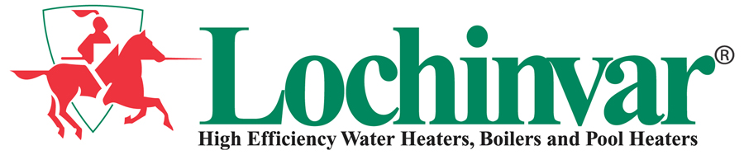
For Immediate Release

LOCHINVAR® CORPORATION HONORED BY DEPARTMENT OF DEFENSE
2008 Secretary of Defense Employer Support Freedom Award Recipients Announced

Lebanon, TN – July 2008 – Lochinvar Corporation, a leading manufacturer of high-efficiency water heaters, boilers and pool heaters, has been named among the 2008 Secretary of Defense Employer Support Freedom Award recipients. The Freedom Award is the highest recognition given by the U.S. Government to employers for their outstanding support of employees who serve in the National Guard and Reserve. The award will be presented to Lochinvar and 14 other employers at a formal ceremony on Sept. 18, 2008 at the Ronald Reagan Building and International Trade Center in Washington, D.C.
This year, a record number of National Guard and Reserve members or their family members nominated their employers for outstanding support. A national selection board comprised of senior Defense officials reviews the submissions and selects the recipients for the award. Included among the 2,199 nominations was a letter from William M. Jacobs, a Manufacturing Engineering Manager at Lochinvar and a Platoon Sergeant for R Troop 4/278 Air Calvary Regiment Tennessee Army National Guard.
In his letter, Jacobs expresses his gratitude for Lochinvar's generosity and support that touched him, his Unit and Task Force as well as many others in the United States Military. "Before, during and after my 16 month deployment to Kandahar,
- more -

LOCHINVAR HONORED BY DEPARTMENT OF DEFENSE - PAGE TWO
Afghanistan, I've watched proudly as Lochinvar, its ownership and employees have dedicated time, money and resources without hesitation to help support the citizen soldiers and full-time service members," stated Jacobs. "Words cannot express how much it means for me to be part of this organization, or the positive impact Lochinvar had and continues to have on the soldiers and service members of Tennessee and the United States of America."
From a significant monetary donation to help start up and support the unit Family Readiness Group, to multiple shipments of gifts, food and supplies collected by employees, the Lochinvar team aimed to provide positive and uplifting moments during an otherwise less than comforting experience. When the unit sent a long list of requested items, Lochinvar employees fulfilled each request, including 200 pounds of top soil, grass seed and fertilizer to build the only plot of grass in Kandahar, which was enjoyed by soldiers, airmen and NATO forces throughout the Task Force. A library was created with the shipments of books and DVDs, which were made available to all of the soldiers. In an attempt to bring seasonal gifts to the troops, a holiday shipment brought the soldiers cards, wrapped presents and a decorated six-foot Christmas tree, and a summer shipment delivered inflatable pools to help fight the heat.
In addition to helping the troops, one Lochinvar employee's daughter even organized a drive at her high school to gather small stuffed animals for the children of Afghanistan. The stuffed animals were sent to a field hospital and given to injured children in an effort to lift their spirits.
"All of us at Lochinvar take great pride in our employees and their families who serve in the United States Military, and we aim to support them in any way possible,"
- more -

LOCHINVAR HONORED BY DEPARTMENT OF DEFENSE - PAGE THREE
stated Bill Vallett, Jr., president of Lochinvar Corporation. "I'm so impressed with the generosity of each of our employees who stepped up and helped make a difference – the Freedom Award honors the outstanding efforts of each and every one of them."
To show their appreciation, Jacobs' unit flew an American flag on a combat mission while in Kandahar. The flag was sent to Lochinvar with a photo and certificate, which are prominently displayed in the employee entrance at the company's headquarters.
After Jacobs' return, the Lochinvar team continued their mission by adopting the unit of another employee's Marine daughter in Fallujah, Iraq. They continue to collect goods and supplies that are shipped overseas to troops fighting the war on terrorism.
In addition to the Freedom Award, Lochinvar has also been presented with the Patriot Award, Concord Minute Man trophy for Outstanding Support of the Unit, the Men and Women of Army National Guard and the "Above and Beyond Award."
Lochinvar Corporation is a leading manufacturer of high-efficiency water heaters, boilers, pool heaters and storage tanks. Based in Lebanon, TN with facilities in Detroit, Orlando, Tampa, Pompano Beach, Dallas and Philadelphia, Lochinvar stocks all products in all locations. For more information about Lochinvar, contact: Lochinvar Corp., 300 Maddox Simpson Parkway, Lebanon, TN 37090; Phone: (615) 889-8900; Fax: (615) 547-1000; www.Lochinvar.com. For media inquiries, please contact Emily Towey at (312) 946-6143 or etowey@msinet.com.
# # #

